CS 255 System Design Document

UML Diagrams

UML Use Case Diagram
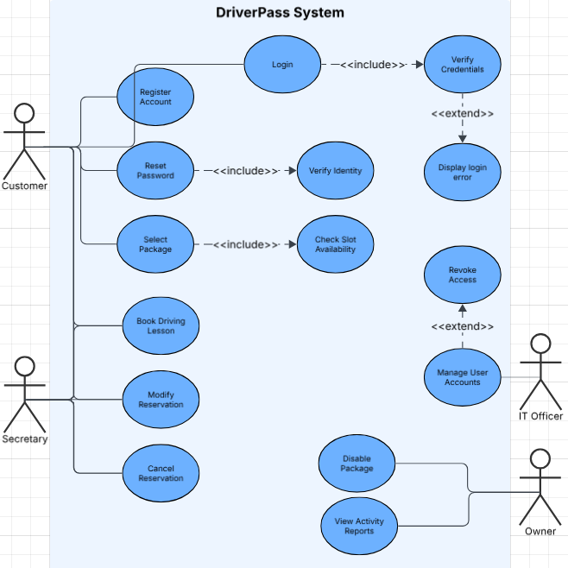

UML Activity Diagrams
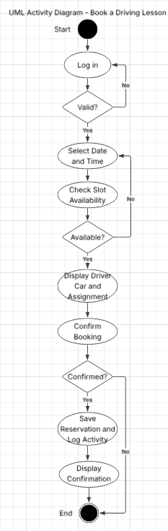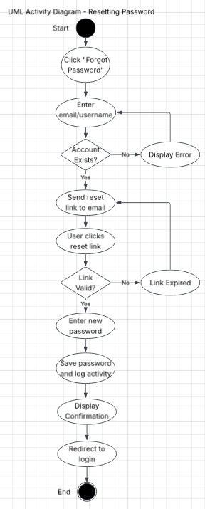

UML Sequence Diagram
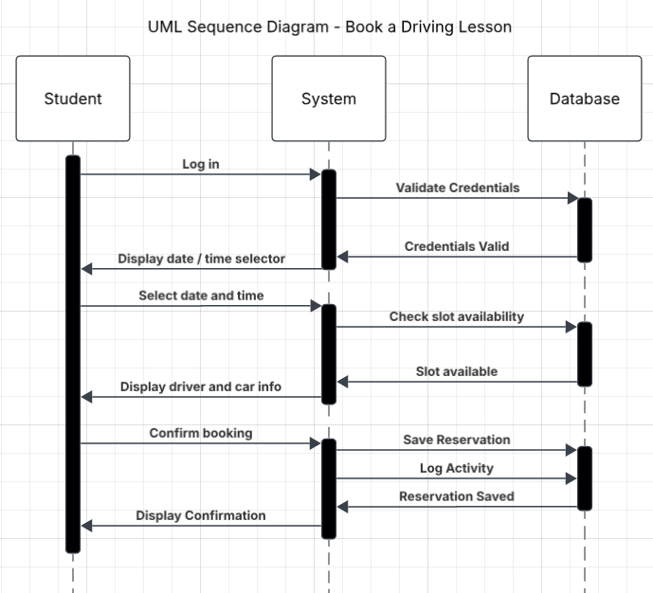

UML Class Diagram
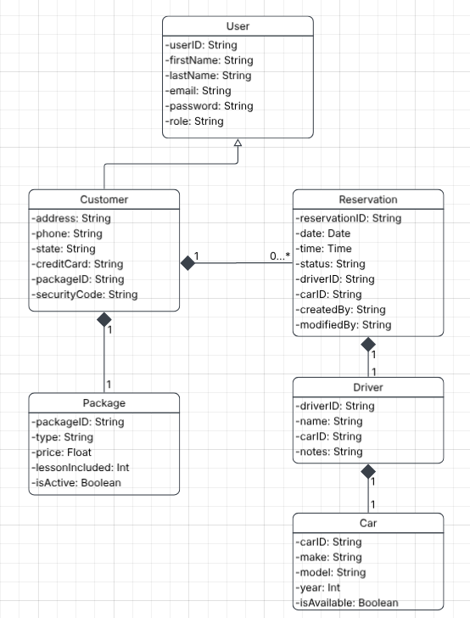

Technical Requirements

The DriverPass system requires a cloud-based hosting environment to support its web application which would eliminate the need for on-site server hardware. The platform must be accessible through any modern web browser on both desktop and mobile devices which means no proprietary software or operating system is required on the client side. The back end will require a relational database to store and manage user accounts, reservation records, package information, and activity logs, with the cloud provider handling backups and security infrastructure. Secure HTTPS connections must be in place to encrypt all data exchanged between the client and server. The system will also require an integration with the DMV notification service or API to receive automatic content updates and must support data export in a format compatible with Excel for reporting purposes.

